20cys281

Os lab work

m.charan kumar reddy

cb.en.u4cys21041

1. #include <pthread.h>

#include <stdlib.h>

#include <stdio.h>

#include <unistd.h>

void *printWelcomeMessage(void *names) {

sleep(7);

char *name = (char *)names;

printf("\n[THREAD] Hello, Welcome %s.", name);

pthread_exit(NULL);

}

int main () {

pthread_t threads[15];

char names[10][15] = {"Amritha","Praveen","Saurabh","Sangeetha","Lakshmy","Srinivasan","Ramaguru"};

int result;

for(int i = 0; i < 7; i++ ) {

printf("\n[MAIN] Creating thread, %d", i);

result = pthread_create(&threads[i], NULL, printWelcomeMessage, (void *)names[i]);

if (result) {

printf("Error in creating thread, %d ", result);

exit(-1);

}

}

pthread_exit(NULL);

}

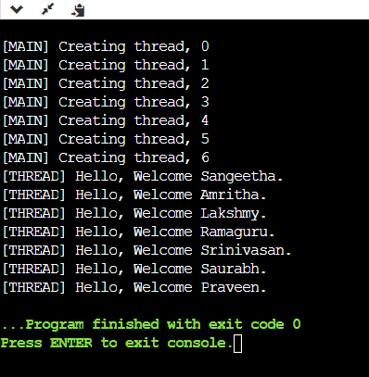

2. #include <pthread.h>

#include <stdlib.h>

#include <stdio.h>

#include <unistd.h>

void *printWelcomeMessage(void *threadid) {

sleep(10);

long tid = (long)threadid;

printf("\n[THREAD] Hello, Welcome %ld.", tid);

pthread_exit(NULL);

}

int main () {

pthread_t threads[7];

char names[10][15] = {"Amritha","Praveen","Saurabh","Sangeetha","Lakshmy","Srinivasan","Ramaguru"};

int result;

for(int i = 0; i < 7; i++ ) {

printf("\n[MAIN] Creating thread, %d", i);

result = pthread_create(&threads[i], NULL, printWelcomeMessage, (void *)&threads[i]);

if (result) {

printf("Error in creating thread, %d ", result);

exit(-1);

}

}

pthread_exit(NULL);

}

3. #include <pthread.h>

#include <stdlib.h>

#include <stdio.h>

#include <unistd.h>

struct number {

int a;

int b;

};

void *addition ( void *s){

struct number *z = (struct number *)s;

printf("Adding %d and %d gives %d\n",z->a,z->b,z->a + z->b);

pthread_exit(NULL);

}

int main(){

int result;

pthread_t threads[5];

struct number k[5];

for ( int i = 0; i < 5; i++ ){

scanf("%d", &k[i].a);

scanf("%d", &k[i].b);

result = pthread_create(&threads[i], NULL, addition,&k[i]);

if (result) {

printf("Error in creating thread, %d ", result);

exit(-1);

}

}

pthread_exit(NULL);

}

